Using machine learning to improve processing of SuperDARN radar data
Summary
The goal of this project is to improve on an existing machine learning algorithm that classifies SuperDARN radar backscatter. The algorithm looks promising because it can make accurate classifications without using elevation angle, which has proved to challenging using traditional methods. However, the project is new and is in a messy and under-tested state. The accuracy of the algorithm needs to be further verified, and it would be useful to add some new features. The deliverable of the project will be a cleaned-up GitHub toolkit with new features, more testing, and lots of documentation.
Project description
This project will be an extension of an existing project, which classifies SuperDARN radar backscatter as ionospheric scatter or ground scatter using a Gaussian Mixture Model (GMM). The resulting model is about 85-95% accurate when compared to the best known empirical model [Bland et. al. 2014], although true ground-truth labels are difficult to obtain. The GMM model works without using elevation angle measurements, which are only available on certain SuperDARN radars, and which are required by the empirical model. Therefore it may be very useful as a way to improve backscatter classification for radars that do not have the elevation angle.
The algorithm has not been tested on different data sets, and is currently in a messy state and needs to be put into a cleaner version that people can easily download and set up. The first deliverable will be a cleaned up, extensively-tested, and well-documented GitHub repo. Currently the accuracy is being determined by comparison with the Bland et. al. empirical method, but that method is not always reliable, so the next deliverable will be documentation on an independent validation method. The algorithm currently only recognizes two categories of scatter, ground scatter and ionospheric scatter, but it would be very useful to include new categories such as meteor scatter and mixed scatter. The next steps will be to research characteristics of these other scatter types, add them to the algorithm, and produce documentation validating the results. The user will be able to select what type of scatter they are interest in and produce graphs. At the end, if there is enough time, it would be useful to add an interactive graphing page to the Space@VT website, so that visitors can easily access the project and classify different data sets.
Deliverables
- An open-source toolkit with the debugged and tested project, along with documentation
- A report on validation of the GMM algorithm independent of the Bland et. al. empirical method
- Implementation of new scatter categories like meteor scatter and mixed scatter
- A page on the SuperDARN website with interactive functionality, so that a visitor can tune the parameters and use whatever database they choose
Optional deliverables:
If there is any extra time, I will also work on some of these projects:
- Useful statistical additions to the data available from GMM, such as confidence intervals of the predictions which can let the user know how reliable the prediction is.
- Generalize the code to work with new types of data, such as satellite data. This could be especially useful for validating SuperDARN data, so it may be added at that time.
- A publication discussing the project and results.
- Presentation at a SuperDARN workshop over the summer.
Timeline
I will be unavailable the week of 5/14, and available 40 hours per week for the rest of the GSoC session, 5/21 to 8/14.
1: Fixing up the existing code [5/21 to 6/11, 3 weeks]
- Test the algorithm on new data sets – no elevation angle, various latitudes.
- Debug problems that arise which cause the algorithm to not work on certain radars.
- Study the DavitPy coding style to make sure this project follows the guidelines. The final project may or may not be integrated into DavitPy since the library is trying to downsize, but it is closely related, so it should follow a similar coding style.
- Create a GitHub repository with the tested and generalized code.
- Add GitHub documentation on how to set up the project, and how well it works on different types of data.
2: Validating the algorithm independently [6/11 to 7/09, 4 weeks]
- Research methods of validating radar scatter. Start with how the Bland et. al. method was validated. Look at data collected by satellites for comparison. Also make note of any methods for validating the types of scatter which will be added later, including mixed scatter and meteor scatter.
- Based on that research, write code to test the GMM predictions against validation data.
- If some problems become apparent from that testing, attempt to debug.
- Produce a report on the results of validation, and update the GitHub repository with the new code and documentation.
3: Adding new types of scatter [7/09 to 7/30, 3 weeks]
- Investigate characteristics of other types of scatter, and look into which categories will be most useful to researchers. See if there are any existing tools to classify these other types of scatter. Look for data to use as validation data.
- Add the new categories to the GMM algorithm.
- Test accuracy and document.
4: Adding to the website and wrapping up the project [7/30 to 8/13, 2 weeks]
- Communicate with the team that is re-vamping the Space@VT website to learn the system for creating interactive graphing pages.
- Set up a dummy webpage on the Space@VT site with the desired interface, then slowly add functionality.
- Also use this time to clean up and improve on documentation
- Submit code, project summary, and final mentor evaluation by the 8/14 deadline

Benefits to the Community
Improving the way we classify radar backscatter puts better tools in the hands of researchers studying the Earth’s atmosphere, solar wind, substorms, and other space phenomena. Many existing methods for classifying backscatter rely on elevation angle, which is not reliably available on all SuperDARN radars. Other methods are biased to classify low-velocity ionospheric scatter (IS) as ground scatter (GS), in order to obtain clean IS data, but that method causes them to exclude a certain amount of low-velocity IS data. This method will provide a way to more reliably classify scatter without needing to use elevation angle, and will separate GS and IS with less bias. As a result, more good-quality data will be available from SuperDARN radars, including from those radars that do not reliably measure elevation angle.
Task report
I. Task Summary:
The objective of this project is to predict the Disturbance Storm Time (DST) index given Interplanetary Magnetic Field (IMF) data, particularly the Z component of magnetic field. The project uses a neural network to model a year of IMF data and predict DST data. The resulting model predicts the general trend of DST well, but it usually fails to predict the exact value. However, this is just a simple prototype, and there are a number of improvements that could possibly improve the accuracy.
II. Task Background:
The Disturbance Storm Time (DST) index measures a magnetic field produced by ring current flowing around the earth's equator. During periods of disturbed space weather, the ring current will increase, causing a larger magnetic field. Negative values of DSV indicate that the induced magnetic field opposes the Earth's magnetic field.
The Interplanetary Magnetic Field (IMF) is a magnetic field produced by solar wind, which is plasma that has been ejected from the sun (coronal mass ejection). NASA's OMNI database contains IMF measurements taken by near-earth spacecraft and time-shifted to Earth's bow shock nose, which is the region at the tip of the cone-shaped outer region of magnetosphere, closest to the sun.
Since solar winds cause disturbances in the Earth's ring current, these two measurements are closely related. In particular, the Z-component of the IMF is roughly perpindicular to the Earth's ring currents, so it has the greatest influence via electromagnetic induction.
III. Task Problem:
Predicting the effects of solar wind on the Earth's magnetosphere could be useful for radio communications and scientific research. We can use machine learning algorithms on IMF data, particularly the Z-component of magnetic field, to try to predict DST. Since solar wind moves much slower than light, taking several days to reach Earth, this could enable us to anticipate what kind of ring currents disturbances will occur in response to an observed solar coronal mass ejection.
IV. Task Solution:
Since we have both the input data (IMF Bz) and the output labels (DST), this is a supervised learning problem. Neural networks are good at capturing relationships between input and output that may or may not be linear, and they usually work well, so I chose to model the data using a neural network. I implemented it using SciKitLearn's MLPRegressor with the ReLU activation function, and 4-fold cross-validation to test the accuracy. The only feature was IMF Bz data from the full year of 2015 (1-hour averages), and the label was the DST for the same time period. I used the 1-hour average Bz data because the DST is only reported once per hour.
At first, the predictions followed similar trends to the ground truth labels for negative DST, but would not make any prediction above a certain threshhold, so it did not predict positive DST well. This turned out to be a problem with the ReLU activiation function, which sometimes has problems if input data is a mix of positive and negative values or is not scaled a certain way. To fix this problem, I multiplied all the Bz data by 100, and added the minimum Bz value so that all the data was positive or 0. This resulted in predictions that did not cut off at a threshhold value. The R^2 value was rather low at around 0.1-0.2, because the predictions tend to follow the same trend, but are rarely exactly the same as the ground truth labels. I tested neural network layer sizes from 1-100, and found anything 5 or above had similar accuracy, so I used 5 layers for best efficiency and accuracy. I also experimented with adding different features including proton density and plasma flow speed from the IMF data set, but found they decreased accuracy. This may indicate that they also need some scaling and preprocessing, or they may not be well-correlated with the DST.
Images below show the predictions vs. truth over a year, as well as two zoomed-in time periods of the neural network working well and not working well. If you are viewing this report as plain text, you can find the graphs at:
https://github.com/e-271/SpaceVT-GSoC-Demo/report

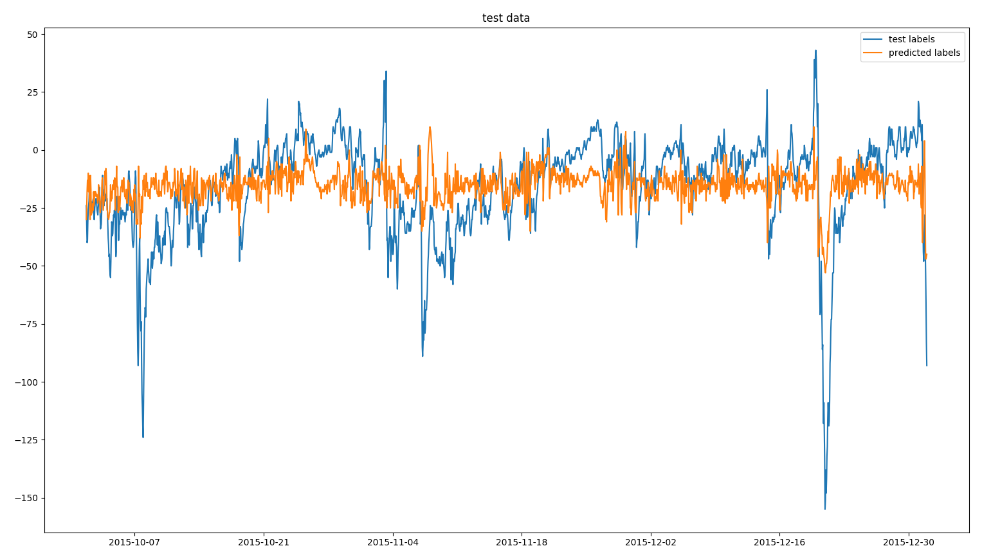
Image 1: Recorded DST and predicted DST over 3 months
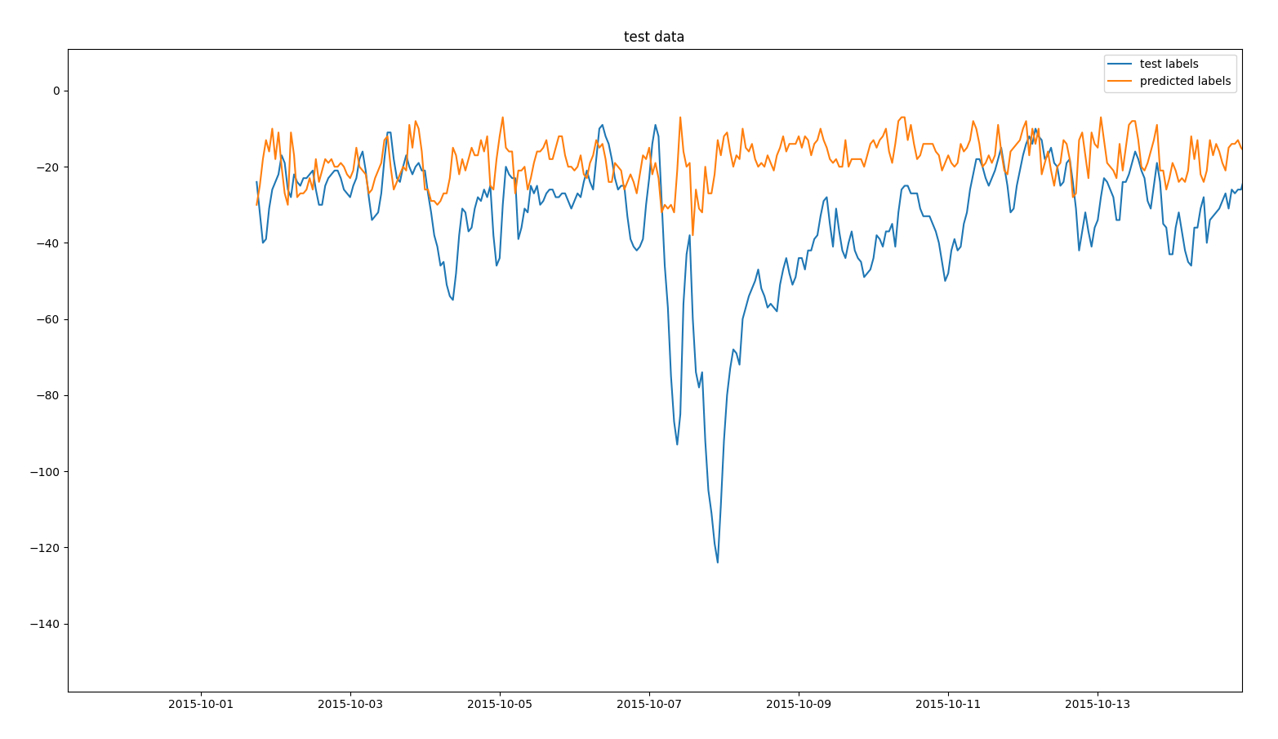
Image 2: Zoomed-in section of image 1. Predictions sometimes follow trend line well, but often does not predict major spikes.
V. Task Conclusions:
Neural networks are a promising method for predicting the general trend of DST data, but a neural network trained using only Bz usually fails to predict the exact value of DST. It is possible that adding new features could increase the accuracy. The new features will need to be carefully selected and scaled for the neural network. It's also possible that there is some time lag between the Bz and the DST, but since we are using 1-hour averages it would need to be on that same timescale to have a significant effect. Another potential way of improving this algorithm is simply to give it more data - I used just one year, but IMF data is available as far back as 1963, and DST data is available from 1957. Training the network on 50 years of data instead of just 1 might increase the accuracy a lot. In conclusion, this algorithm is fairly good at predicting the general trend of DST, but is inaccurate in predicting the actual values. However, there are many ways that the value predictions could potentially be improved.
VI. Task References:
OMNI data documentation
https://omniweb.gsfc.nasa.gov/html/HROdocum.html
Source of DST data
http://wdc.kugi.kyoto-u.ac.jp/index.html
Source of IMF data
https://cdaweb.gsfc.nasa.gov/pub/data/omni/
GitHub page for this project
https://github.com/e-271/SpaceVT-GSoC-Demo
Bio-sketch
I am studying Computer Engineering at Virginia Tech, and will graduate with a Bachelor of Science in December 2018. My education background includes classes in statistics, linear algebra, machine learning, and artificial intelligence. I worked on this project previously with one of the SuperDARN@VT members as part of the machine learning class, contributing to background research, documentation, and some coding. My work background includes designing a website front-end for a machine learning script. I have also done a research internship where we investigated using Android 7’s new GNSS data logging capabilities to get centimeter-level positioning, which we found was possible on devices with a certain GNSS chip. I served as the coding lead for a Python toolkit we created to process data and graph the experiment results. I am interested in this project because I think that machine learning algorithms have a lot of potential for improving our understanding of scientific data, and I want to use machine learning to develop tools that will help researchers study space.

